



Accountability Agreement

**2024-25**

# ‘Leaders have selected a curriculum which meets well the needs of the community that they serve. They have a strong focus on providing an education which will enable learners to gain employment.’ **Ofsted April 2022**

*‘Lambeth Council is proud to be supporting this strategy, which aligns perfectly with our ambitions for our diverse communities in Lambeth.’* **Councillor Jacqui Dyer, Deputy Leader Lambeth Council and SBC Board Trustee**

# ‘The opening of the London South Bank Technical College at Nine Elms is a significant development for London's skills provision. With investment from Mayor of London, this exciting new college will help Londoners gain the industry relevant skills across areas including science, technology and design. We look forward to continuing to work with the college as they continue to support Londoners, employers and the local community.’ **Jules Pipe, Deputy Mayor,**

**Planning Regeneration and Skills**

*‘The South Bank Employers' Group recognises the vital role that South Bank Colleges plays in engaging with local employers, and really values the College's commitment to engagement and partnership working.’* **Nic Durston, Chief Execu�ve South Bank Employers Group**



## South Bank Colleges Accountability Agreement 2023-24

LSBU Group includes London South Bank University, South Bank Colleges, consisting of Lambeth Gateway College and London South Bank Technical College (LSBTC), and London South Bank University 6th Form. Each has a strong professional and technical focus.

The Group is unique in its creation of step on – step off educational pathways leading from gateway qualifications through to T-Levels and the new Higher Technical Qualifications then through to graduate and postgraduate level study. LSBU Group’s Passmore Centre for Apprenticeships is the employer interface for our Group apprenticeship offer enabling employers to access apprenticeship pathways from level 2 through to level 8.

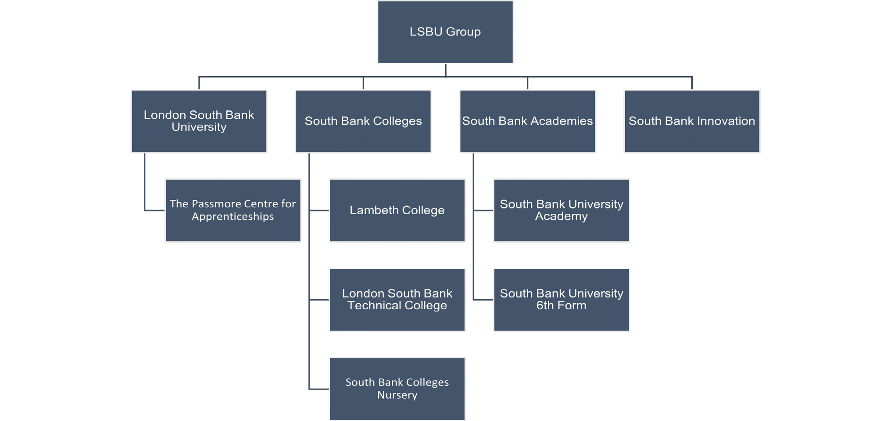

## Purpose

**As part of the LSBU Group our vision is:**

To transform lives, communities, business and society through applied education and insight.

## Access to Opportunity

Through local and global partnerships, we will create opportunities for individuals, businesses

and society and seek to remove barriers to opportunity and success.

## Student success

We will be recognised for our inclusive, high-quality teaching and learning and the support we provide to students that enables them to be successful.

## Real World Impact

As an anchor organisation in south London, we embrace our civic responsibilities to those that live, work and learn in the area and our duty to have a positive economic impact on individuals, communities and businesses in the region.

## Fit for the Future

Establishing a sustainable, responsive model for further education, with high quality physical

and digital learning environments and a highly skilled and inclusive workforce.



South Bank Colleges, comprising Lambeth Gateway College and London South Bank Technical College, exists to meet the needs of those that live, work and learn in south London. We believe that South Bank Colleges has a central role to play as an anchor organisation in south London working in close partnership with industry, the public sector and local authorities, to provide a highly inclusive education and responsive oﬀer.

We are fully committed to the integral part that we, as a civic minded organisation, have to play in contributing to the improved health and economic wellbeing of our local residents and communities. We recognise the vital role we play in providing access to lifelong learning for young people and adults. We pride ourselves on our inclusive approach that puts access to education at the heart of our work, whether that is through gateway qualiﬁcations in English, maths, ESOL (English for Speakers of Other Languages) and employability skills or through technical and professional education.

Lambeth is known for having huge ambition, energy and opportunity as well as a strong history of openness and diversity. It is home to entrepreneurs and innovators - people who have hopes of changing the lives of others and their own. As career focused colleges, we are uniquely placed to support life-long learning in the borough through our Career Progression Pathways Model of Professional and Technical Education – and our commitment to responding to emerging local skills needs.

## Context and Place

South Bank Colleges is based in the London Borough of Lambeth and has three main campuses, based in Clapham, Brixton and Nine Elms. It operates in a key sub region of London with extensive skills needs, low levels of participation and pockets of high levels of deprivation.

Lambeth College became a designated Institution under section 28 of the Further and Higher education Act 1992, and is operated by South Bank Colleges, a wholly owned subsidiary of London South Bank University

The current cohort of 16-19 (1,200) and adult learners (6000) at the college is drawn from across several South London boroughs, London Borough of Lambeth are where most learners are from, followed by Southwark, Wandsworth and Croydon.

The London Borough of Lambeth is in South London with a population of over 317,000. The borough has a large racial minority population (43.9%) and was ranked 69th on the Indices of Deprivation in 2019 (1 - highest 316 - lowest). According to Annual Population Survey data in September 2022 82% of 16–64 year-olds were in employment, compared to the national average of 75.5% and 75.8% across London.

As of September 2022 3.8% of Lambeth’s residents were unemployed compared to 3.7% nationally, and a further 14.4% were economically inactive, compared to 21.6% across the UK. The learner make-up at SBC reflects the background population of the borough. Our staff profile is representative of the communities we serve.

## Lambeth Gateway College

The focus of the gateway college brand is to support those furthest from the workplace and those most at risk of not benefiting from high quality education, to access a range of ‘gateway’ qualifications that support entry to employment and/or progression to level 3 and 4 technical education.



The gateway college provision includes:

* 14-16 year old alternative education pathways
* 16-19 year old ESOL pathways
* 16-19 employability programmes
* 16- 25 year old SEND provision
* English, maths and digital skills programmes for 16-19s and adults
* Pre-access provision
* Pre-apprenticeship programme
* Sector Based Work Academy Programmes (SWAPS)
* Adult ESOL

All courses at the gateway college combine English, maths and digital skills with a range of employability and vocational training to support progression to level 3 and 4 qualifications and/or employment.

## London South Bank Technical College

London South Bank Technical College brand has been established to deliver growth of high quality vocational and technical education with a strong focus on growing participation in level 3 and 4 qualifications for young people and adults as well as providing robust progression routes for those at level 1 and 2.

The new technical college’s STEAM building at Nine Elms which opened in Spring 2023 has been purpose built with industry standard facilities to deliver increased participation in

* Construction and the Built Environment
* Green skills
* Science
* Health and Dental
* Engineering
* Computing
* Creative and digital

With new provision designed for young people and adults across:

* T levels
* Access courses
* HNC/HTQs* (from 2024)
* Apprenticeships
* Free Courses for Jobs

Phase two development is underway with a new Health and Life Sciences centre and a Business, Design and employers’ hub due to open in September 2026. Key local stakeholders are involved in the planning and design of the new LSBTC facilities to ensure they fully meet national, regional and local skills needs. Key stakeholders including GSTT, Eastman Dental Hospital, South Bank Employers Group and SC1. GLA, Lambeth and Southwark councils are involved in ensuring the curriculum offer meets the needs of local residents and supports progression into good jobs in south London and beyond.

The college is particularly focussed on increasing participation at levels 3 and 4 and will achieve this in part through the introduction of T-levels, HNC/HTQs and an expansion of its apprenticeship offer in the areas outlined above.



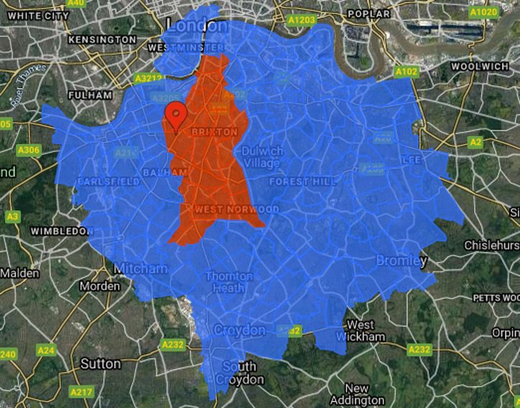

## LSIP

Priority sectors for the Central London Forward area have been identified on the basis of total employment size and relative size in comparison with national employment, also taking into account the Mayoral priorities, and are as follows:

* + Health and social care
  + Creative, arts and recreation
  + Financial and professional services
  + Information & communication
  + Retail/hospitality

This LMI data aligns with the colleges estates and curriculum strategy as agreed as part of our section 28 designation status.

## Approach to developing the annual accountability statement

The development of the colleges’ strategic and curriculum plan has involved engagement with a range of key stakeholders including the GLA, local councils, employers, SBC staff and students and LSBU Group.

We have responded directly to LMI data accessed via EMSI, RCU and our LSIP along with key policies such as the Skills White paper (national), Skills for Londoners (regional), and Lambeth Council’s Skills and Employment strategy (local).

SBC sits as part of the GLA with Central London Forward connecting in with the 12 central London boroughs of which Lambeth is one. The college is a member of BusinessLDN which is leading the Central London LSIP.



London LSIP in partnership with the Federation of Small Businesses London (FSB), London Chamber of Commerce and Industry (LCCI), and Confederation of British Industry London (CBI), with the backing of the Mayor of London and London government. They have identified several target sectors for the LSIP, aligned with the Mayor’s priorities: creative, tech, health and social care, hospitality, and construction. They are also focusing on labour market inclusion, digital, and green skills as cross-cutting themes.

BusinessLDN presented their findings to the Lambeth Council Employment and Skills Board which the college is a member of.

The college leadership team are represented on a number of key strategic boards with membership of employers, employer representative Groups, and councils. This engagement directly supports the strategic planning of the curriculum offer at SBC. Membership boards include:

* Lambeth Council Employment and Skills Board
* Lambeth Council Apprenticeship Group
* Lambeth Made
* Lambeth Children and Young Peoples Board
* Lambeth Youth Justice Board
* Lambeth Climate Partnership
* South Bank Employers Group
* City of London Skills for a Sustainable Taskforce strategy group
* GLA University Vocational Awards Council (UVAC) board member
* Linking London Apprenticeship Practitioner Group
* SC1 Employment and skills Group
* AELP Apprenticeship Special Interest Group APPG Sponsor (via LSBU of course)

The Executive Principal and college Principals collaborate with local colleges through formal groups including those referred to above, through the Association of Colleges and through local meetings to ensure that a full and relevant regional and local curriculum offer is available for students and employers. The college is involved in pan London college partnerships for Green skills as well as an ESF funded programmes for level 1, level 4 and green skills.

In addition to the above the college has used the reports and data sets noted in the supporting documents section in designing its curriculum offer to meet the following national, regional, local priorities. The curriculum offer is reviewed annually with input from key stakeholders including the GLA, local councils, employers and students.

In summary we have responded to our stakeholders by developing a curriculum that responds to the key priorities below.

|  |  |  |
| --- | --- | --- |
| **Qualification** types | **Sectors** | **Targeted Cohorts** |
| T levels  Free courses for Jobs Apprenticeships HNC/HTQs | Construction and the Built Environment  Green skills Science Healthcare Science Engineering Computing  Creative and digital  Childcare and Education | Racially minoritised groups,  16-19 year olds, 19-24 year olds,  50+ year olds,  people with disabilities |



## Contribution to national, regional, local priorities (linked to the LSIP, our strategy, quality improvement)

|  |  |  |
| --- | --- | --- |
| No. | **24/25 objective** | **Measure of success** |
| 1 | Increase participation of young people and adults in level 3 and 4 technical education. | 10% growth in young people engaged in levels 3 and 4 technical education  8% growth in adults engaged in level 3 and 4 technical education |
| 2 | Expand curriculum offer to directly meet the needs of national, regional and local priority skills needs through T levels, Apprenticeships, MCA, Green Skills Hub. | Centre for Green skills delivers training for 200 plus adults and young people in qualifications that contribute to employment linked to green jobs.  Successfully grow T level and Level 2 T level Foundation offer in   * Health * Healthcare * Science * Digital Production, Design and Development * Design, Surveying and Planning for Construction * Design and Development for Engineering and Manufacturing * Digital Business Services   Successfully Launch new Level 4 offer in   * Science * Forensic Science * Healthcare science   And continue to grow L4 participation |
| 3 | Increase Apprenticeship offer to meet local skills priorities and enhance the Group pathways offer | Launch new apprenticeship standards across level 2 and 3 priority skills areas including   |  |  |  |  |  |  |  |  |  |  | | --- | --- | --- | --- | --- | --- | --- | --- | --- | --- | | |  | | --- | | Low Carbon Heating Technician | | Healthcare Support Worker | | Engineering Technician | | Dental Technology  Orthodontic Therapist   |  | | --- | | Business Administrator Apprenticeship (Mindful  Education) | | Team Leader/Supervisor Apprenticeship (Mindful Education) | | |  | |  | |  | | |  | |  | |  | |  | |  | |  | |  | |  | |  | |  | |  | |  | |  | |  | |  | |  | |  | |  | |
| 4 | Embed high quality, English, maths, digital skills and employability focussed programmes across all LGC provision to support positive progression to further education at L2 and/or employment for all gateway  students. | Increase number of adults engaged on Employability programmes including skills boot camps by 20%  Increase progression from LGC to LSBTC by 10% in 24/25 |
| 5 | Publish sector pathways that map the offer across the LSBU Group and deliver increased engagement in education and training in south London in particular. | 12% growth in young people 6% adults  30% apprentices |



|  |  |  |
| --- | --- | --- |
| 6 | Embed the distinctive SBC education framework across all provision to support SBC graduates being well- prepared for entry to employment and responsive to employer feedback  on work-readiness. | Top 20% percentile for achievement  Close achievement gaps to less than 3% |
| 7 | Provide a distinctive student engagement and well-being framework that is highly responsive in supporting our diverse cohort of students to succeed regardless of  demographic or background. | Improve attendance by 8%  90% positive destination |

**Corporation statement**

On behalf of South Bank Colleges Board of Trustees, it is hereby confirmed that the college plan as set out above reflects an agreed statement of purpose, aims and objectives as approved by the Board at their meeting on the 9th May 2024.

The plan will be published on the college’s website within three months of the start of the new academic year and can be accessed from the following link:

<https://www.southbankcolleges.ac.uk/about-us>

**Supporting documentation**

|  |  |
| --- | --- |
| **Document** | **Link** |
| **LSBU Group Strategy**  **2020- 2025** | <https://www.southbankcolleges.ac.uk/about-us> |
| **SBC 2020 -**  **2025 strategy** | [SBC_Strategy_-_FINAL_Web_Feb_2022.pdf (southbankcolleges.ac.uk)](https://www.southbankcolleges.ac.uk/images/strategy/SBC_Strategy_-_FINAL_Web_Feb_2022.pdf) |
| **SBC Ofsted report**  **SBC Nursery report** | [50182248 (ofsted.gov.uk)](https://files.ofsted.gov.uk/v1/file/50182248)  [2757659 (ofsted.gov.uk)](https://files.ofsted.gov.uk/v1/file/2757659) |
| **DfE**  **document** | [Skills for Jobs: Lifelong Learning for Opportunity and Growth (publishing.service.gov.uk)](https://assets.publishing.service.gov.uk/government/uploads/system/uploads/attachment_data/file/957856/Skills_for_jobs_lifelong_learning_for_opportunity_and_growth__web_version_.pdf) |
| **CBI**  **BusinessLDN** | [12640-cbi-reviving-regions_london.pdf](https://www.cbi.org.uk/media/6584/12640-cbi-reviving-regions_london.pdf)  [London Local Skills Improvement Plan | BusinessLDN (previously London First)](https://www.businessldn.co.uk/what-we-do/people/london-local-skills-improvement-plan#planofaction) |
|  | [London Local Skills Report and Annexes – February 2022 - London Datastore](https://data.london.gov.uk/dataset/london-local-skills-report-and-annexes-february-2022) [GLA Economics Skills and Employment Analysis - London Datastore](https://data.london.gov.uk/dataset/gla-economics-skills-and-employment-analysis)  [12640-cbi-reviving-regions_london.pdf](https://www.cbi.org.uk/media/6584/12640-cbi-reviving-regions_london.pdf) |
| **Lambeth Skills and Employment Strategy**  **2020-2023** - | [htps://moderngov.lambeth.gov.uk/documents/s122910/Appendix%202%20-](https://moderngov.lambeth.gov.uk/documents/s122910/Appendix%202%20-%20Skills%20and%20Employment%20Strategy.pdf)  [%20Skills%20and%20Employment%20Strategy.pdf](https://moderngov.lambeth.gov.uk/documents/s122910/Appendix%202%20-%20Skills%20and%20Employment%20Strategy.pdf) |



|  |  |
| --- | --- |
| **Southwark Skills Strategy 2018-2022**  **Economic Strategy (2022-2030)**  **DRAFT** | <https://www.southwark.gov.uk/business/skills-strategy>  [htps://consulta�ons.southwark.gov.uk/corporate-strategy/economic-strategy-22-](https://consultations.southwark.gov.uk/corporate-strategy/economic-strategy-22-30/user_uploads/economic-strategy-2022-27-draft-1.pdf) [30/user_uploads/economic-strategy-2022-27-dra�-1.pdf](https://consultations.southwark.gov.uk/corporate-strategy/economic-strategy-22-30/user_uploads/economic-strategy-2022-27-draft-1.pdf) |
| **Wandsworth Life Skills and Wellbeing Opportunities Services**  **Wandsworth Lifelong Learning Guide 2022-**  **2023 -** | <https://www.wandsworth.gov.uk/media/13154/generic_specification.pdf>  <https://www.wandsworth.gov.uk/media/7026/wandsworth_lifelong_learning_guide.pdf> |